EE5353 Neural Network and Deep Learning

Program Assignment-6

Submitted to

Dr. Michael Manry

Electrical Engineering Department

University of Texas , Arlington

Submitted By

Sunil Joshi

1001789901

Department of Civil Engineering

University of Texas, Arlington

1. **Convulution layers added as suggested in assignment**

1. **Training of model for epochs 10 and 20 respectively**

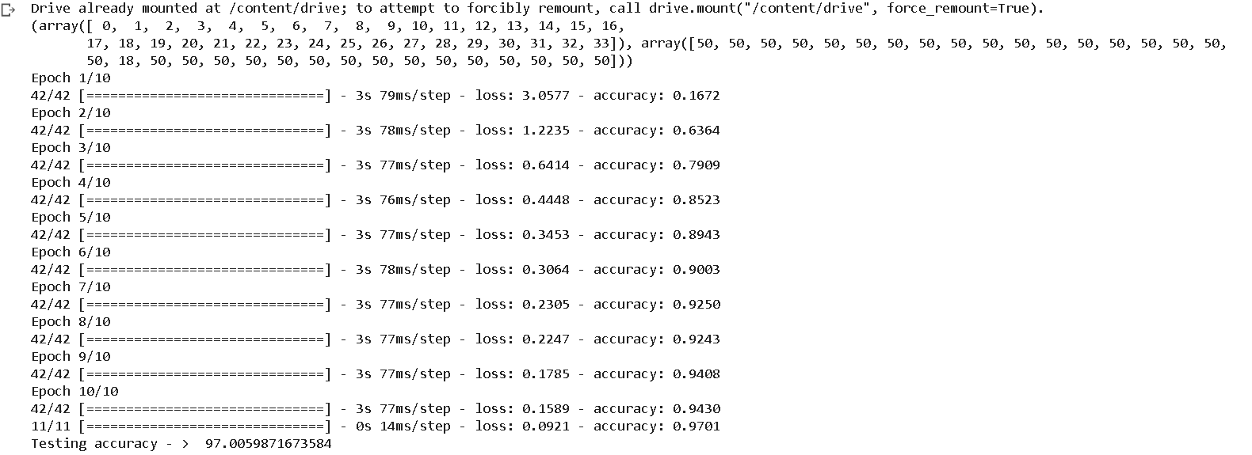

1. **The predicted outcomes of models**

1. **Conclusion:**

The accuracy of model for 10 epochs is 97.0059% and for 20 epochs 98.8023 % which indicates that the increasing in the epochs number better model get trained and result into better accuracy.

1. **Learned from this programming assignment:**
2. Implementation of different CNN layers using collab.
3. The factors which increases the accuracies of model.